Tumbling window trigger

1. Create trigger go to manage->create->

Type->tumbling window

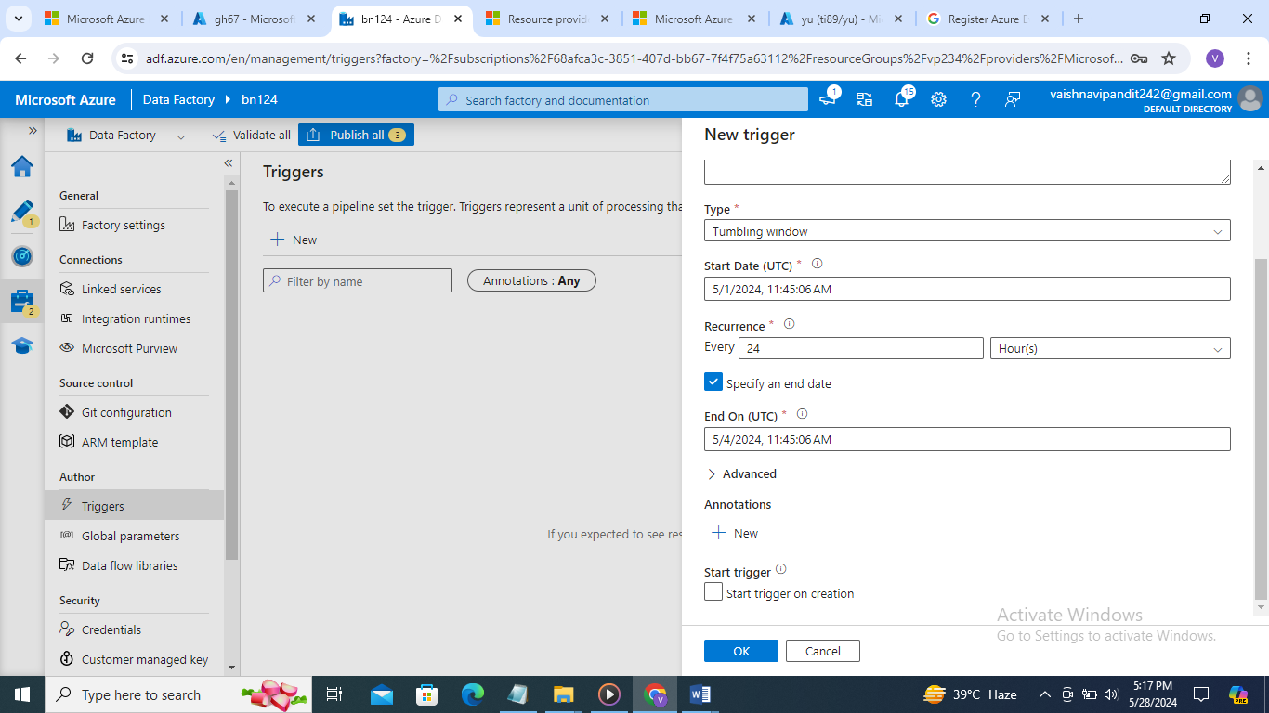

1. Now go to pipeline
2. Create parameters start end

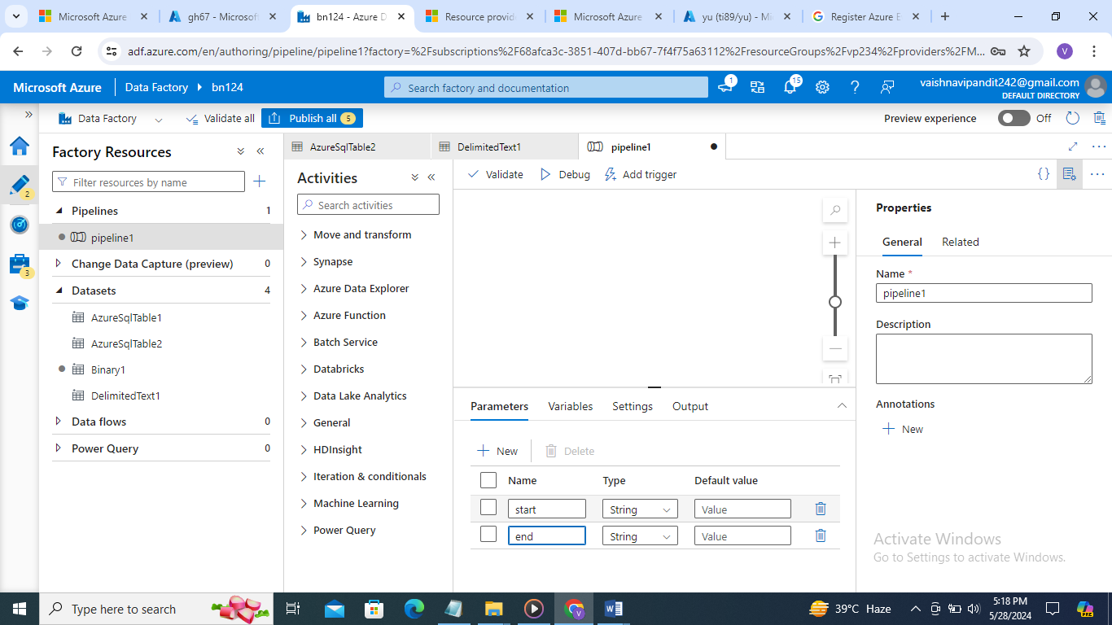

1. And create variable start end

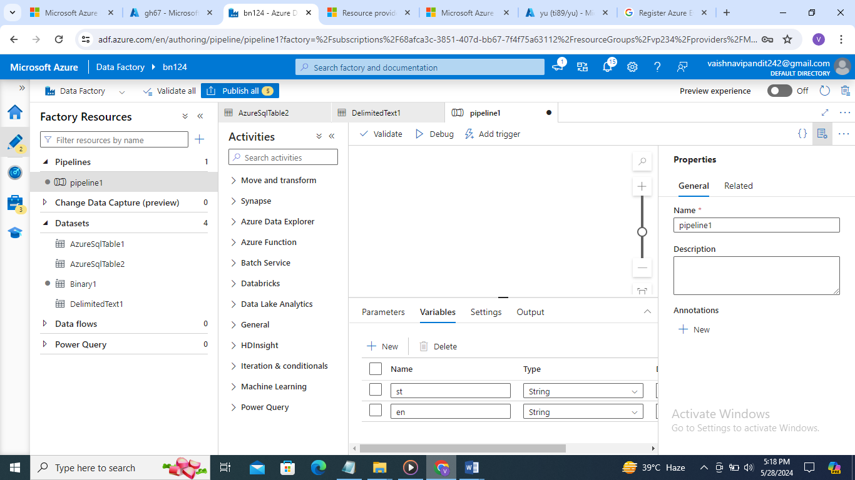

1. Now create set variable activity

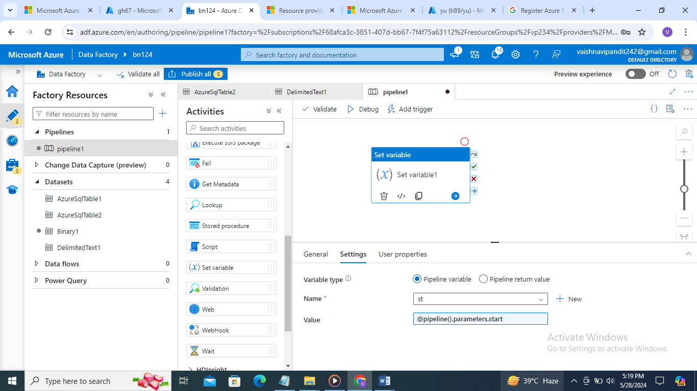

1. Create similarly for second variable
2. Now add trigger it will ask for [parameter@{trigger().outputs.windowStarttime},@{trigger().outputs.windowEndTime}](mailto:parameter@%7btrigger().outputs.windowStarttime%7d,@%7btrigger().outputs.windowEndTime%7d) add this in parmeter

